**1.**Print your name to the screen with every letter being a different heading size.

**INPUT:**

<html>

<head>

</head>

<body>

<h1>THIS IS HEADING<h1>

<h2>THIS IS HEADING</h2>

<h3>THIS IS HEADING</h3>

<h4>THIS IS HEADING</h4>

<h5>THIS IS HEADING</h5>

<h6>THIS IS HEADING</h6>

</body>

</html>

**OUTPUT:**

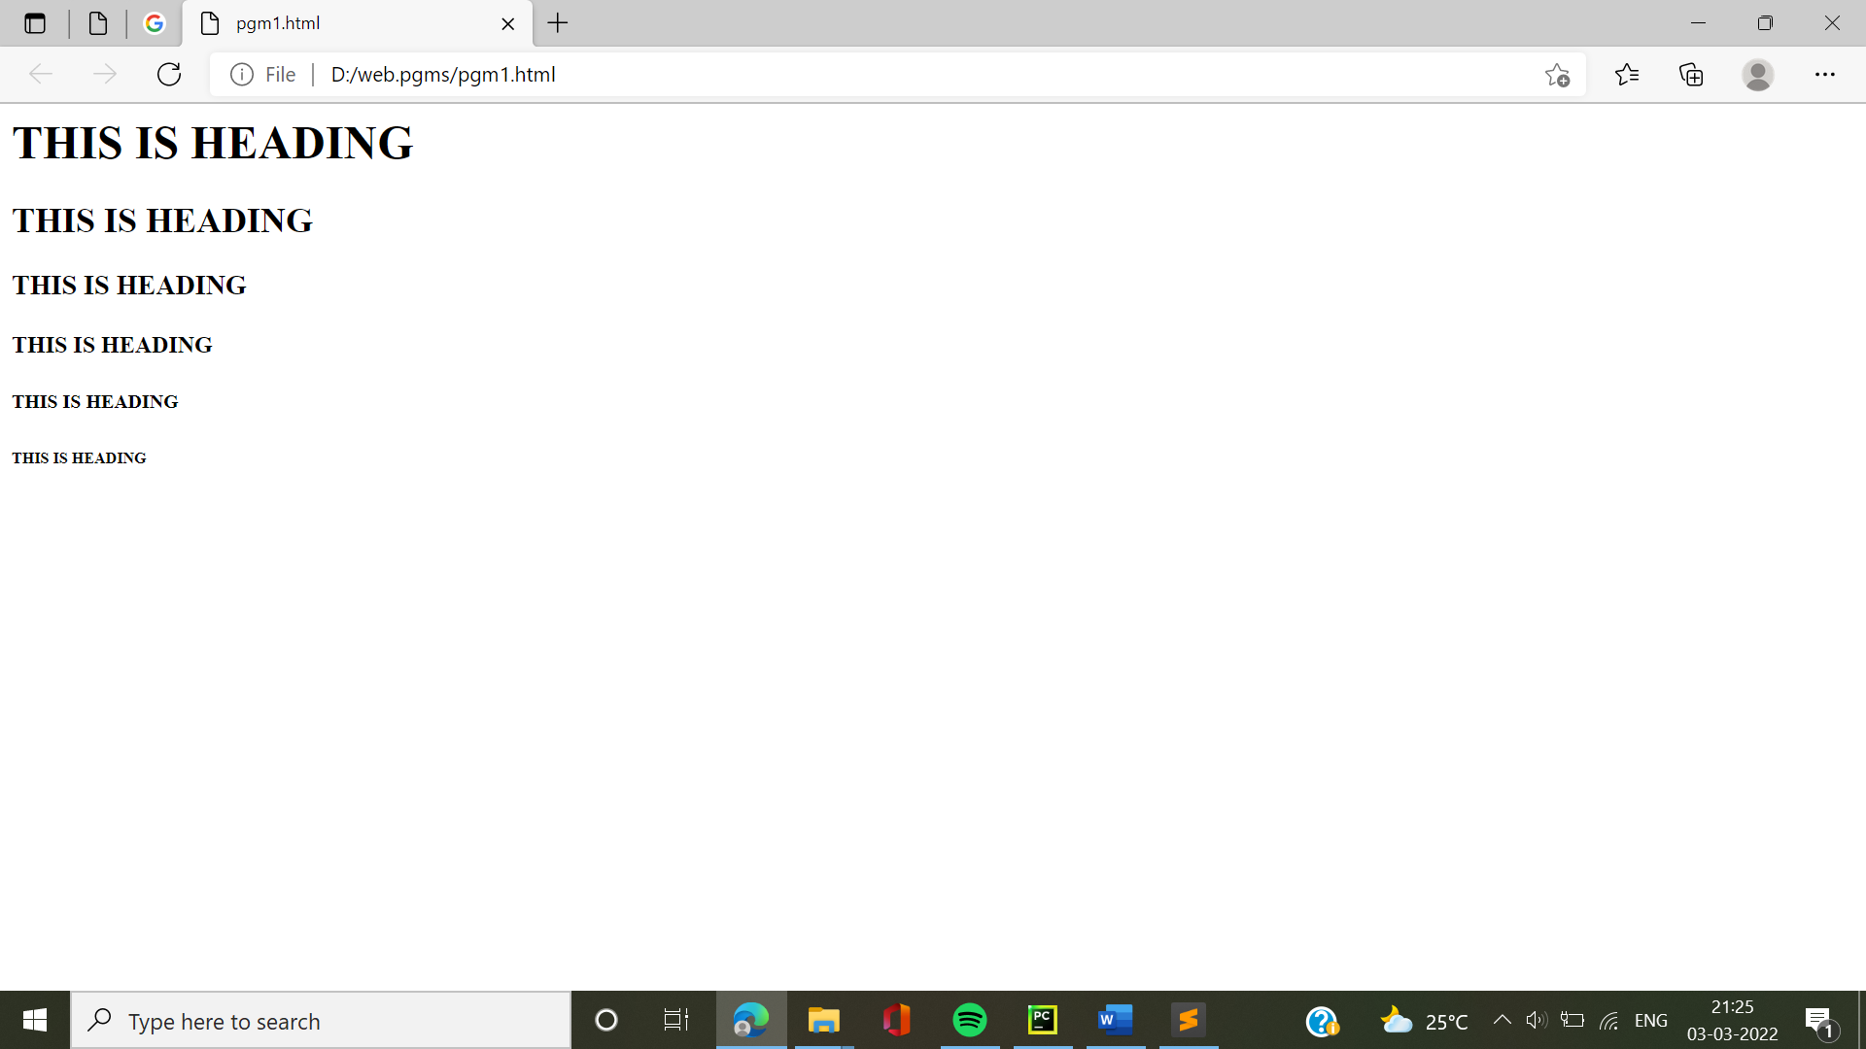

**2.**Display the following text:

H2O

12th April 2016

HTML stands for ~~High Text Markup Language~~

He said <**I am fine**>

**INPUT:**

<html>

<head>

</head>

<body>

<p>H2O</p>

<p>12th April 2016</p>

<p>HTML stands for <del>Hightext Markup Language</del><p>

<p>He said < i am fine > </p>

</body>

</html>

**OUTPUT:**

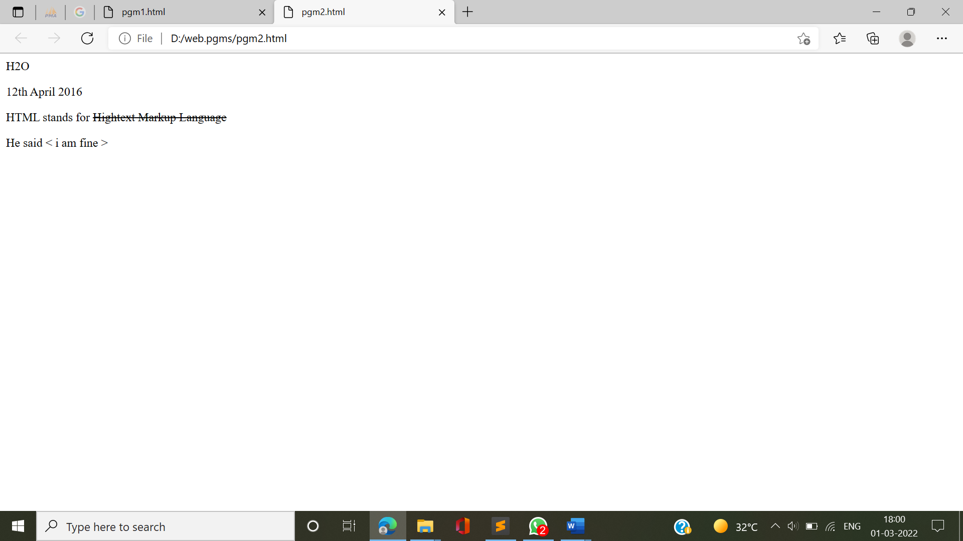

**3.** Print a paragraph with 4 - 5 sentences. Each sentence should be a different font.

**INPUT:**

<html>

<head>

</head>

<body>

<p><font style="font-family:Dubai">The software conception activities include determination of the s/w project needs and overall goals.

<font style="font-family:Arial">The activities are driven management directivies customer input,technology changes and marketing decisions.

<font style="font-family:Corbel light">All the onset of the phase,no formal requirements are written,generally no decisions about hardware/software enviornment are made,and bought and schedules cannot be set in other words,only the feature of the s/w produt and possibility the feasibility of testing them are disscussed.</p>

</body>

</html>

**OUTPUT:**

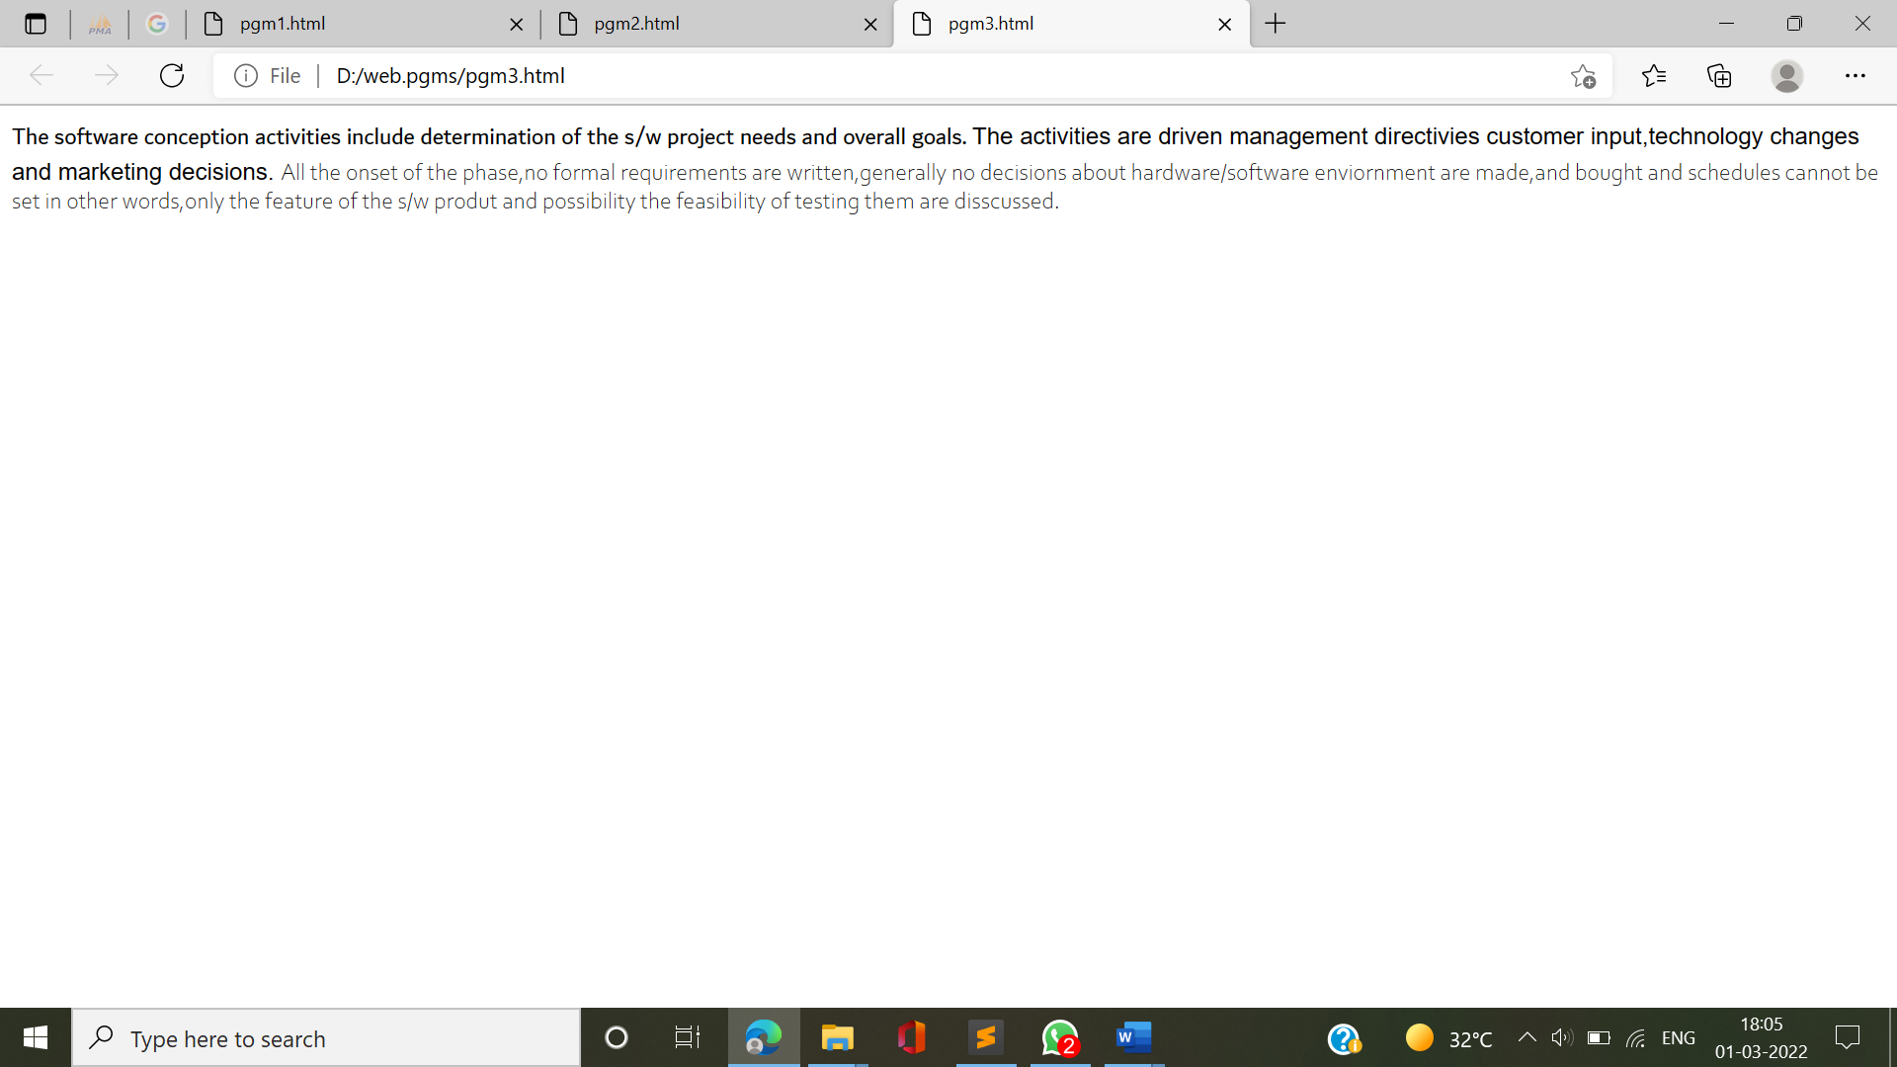

**4.** Print a paragraph that is a description of a book, include the title of the book as well as its author. Names and titles should be underlined, adjectives should be italicized and bolded.

**INPUT:**

<html>

<head>

<title>book</title>

</head>

<body>

<p>One particular book which is recommended reading is <u>The Alchemist</u> by <u>Paulo Coelho</u>.An Andalusian shepherd boy named Santiago travels from his homeland in Spain to the Egyptian desert in search of a treasure buried in the pyramids..It is <b><i>well written and intresting.</b></i><p>

</body>

</html>

**OUTPUT:**

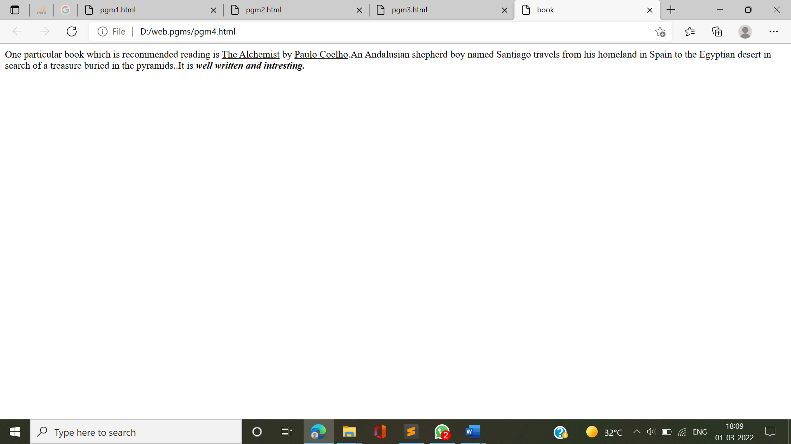

**5.** Print two lists with any information you want. One list should be an ordered list, the other list should be an unordered list.

**INPUT:**

<html>

<head>

<title>lists</title>

</head>

<body>

<b>FRUITS</b>

<ol>

<li>Apple</li>

<li>Orange</li>

<li>Water Melon</li>

<li>Grapes</li>

</ol>

<b>FLOWERS</B>

<ul>

<li>Rose</li>

<li>Lilly</li>

<li>Lotus</li>

<li>Jasmine</li>

</ul>

</body>

</html>

**OUTPUT:**

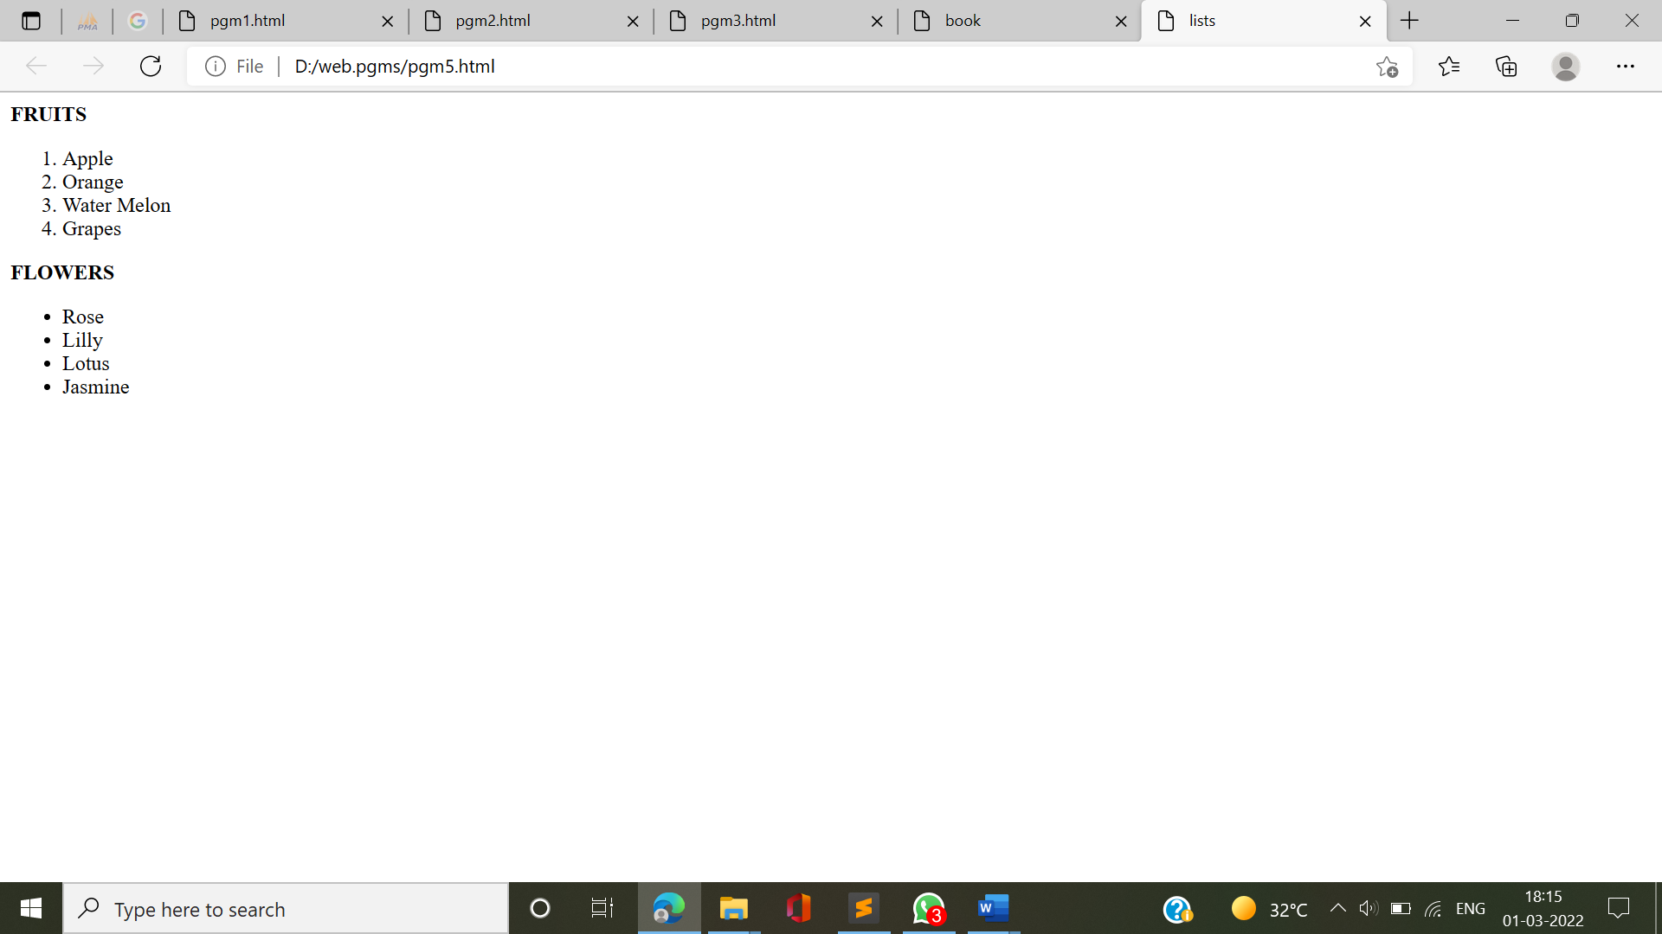

**6.** Prints 10 names with a line break between each name. The list should be alphabetized, and to do this place a subscripted number next to each name based on where it will go in the alphabetized list. (Example: Alan1). Print first, the unalphabetized list with a subscript number next to each name, then the alphabetized list. Both lists should have an <h1> level heading.

**INPUT:**

<html>

<body>

<h1>Unalphabetized list</h1>

<ul>

<li>Anite<sub>3</sub></li>

<br />

<li>Ansona<sub>5</sub></li>

<br />

<li>Bharathi<sub>6</sub></li>

<br />

<li>Sherin<sub>9</sub></li>

<br />

<li>Veena<sub>10</sub></li>

<br />

<li>Rose<sub>7</sub></li>

<br />

<li>Paru<sub>8</sub></li>

<br />

<li>Anna<sub>4</sub></li>

<br />

<li>Amrutha<sub>1</sub></li>

<br />

<li>Anakha<sub>2</sub>

</ul>

<h1>Alphabetized list</h1>

<ul>

<li>Amrutha</li>

<br />

<li>Anakha</li>

<br />

<li>Anite</li>

<br />

<li>Anna</li>

<br />

<li>Ansona</li>

<br />

<li>Bharathi</li>

<br />

<li>Sherin</li>

<br />

<li>Rose</li>

<br />

<li>paru</li>

<br />

<li>veena</li></ul>

</body>

</html>

**OUTPUT:** 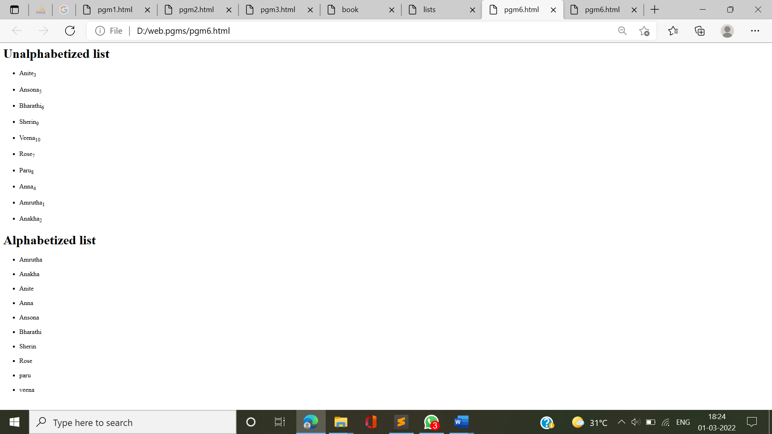

**7.** Print the squares of the numbers 1 - 20. Each number should be on a separate line, next to it the number 2 superscripted, an equal sign and the result.

**INPUT:**

<html>

<body>

1<sup>2</sup> = 1

<br />

2<sup>2</sup> = 4

<br />

3<sup>2</sup> = 9

<br />

4<sup>2</sup> = 16

<br />

5<sup>2</sup> = 25

<br />

6<sup>2</sup> = 36

<br />

7<sup>2</sup> = 49

<br />

8<sup>2</sup> = 64

<br />

9<sup>2</sup> = 81

<br />

10<sup>2</sup> = 100

<br />

11<sup>2</sup> = 121

<br />

12<sup>2</sup> = 144

<br />

13<sup>2</sup> = 169

<br />

14<sup>2</sup> = 196

<br />

15<sup>2</sup> = 225

<br />

16<sup>2</sup> = 256

<br />

17<sup>2</sup> = 289

<br />

18<sup>2</sup> = 324

<br />

19<sup>2</sup> = 361

<br />

20<sup>2</sup> = 400

</body>

</html>

**OUTPUT:**

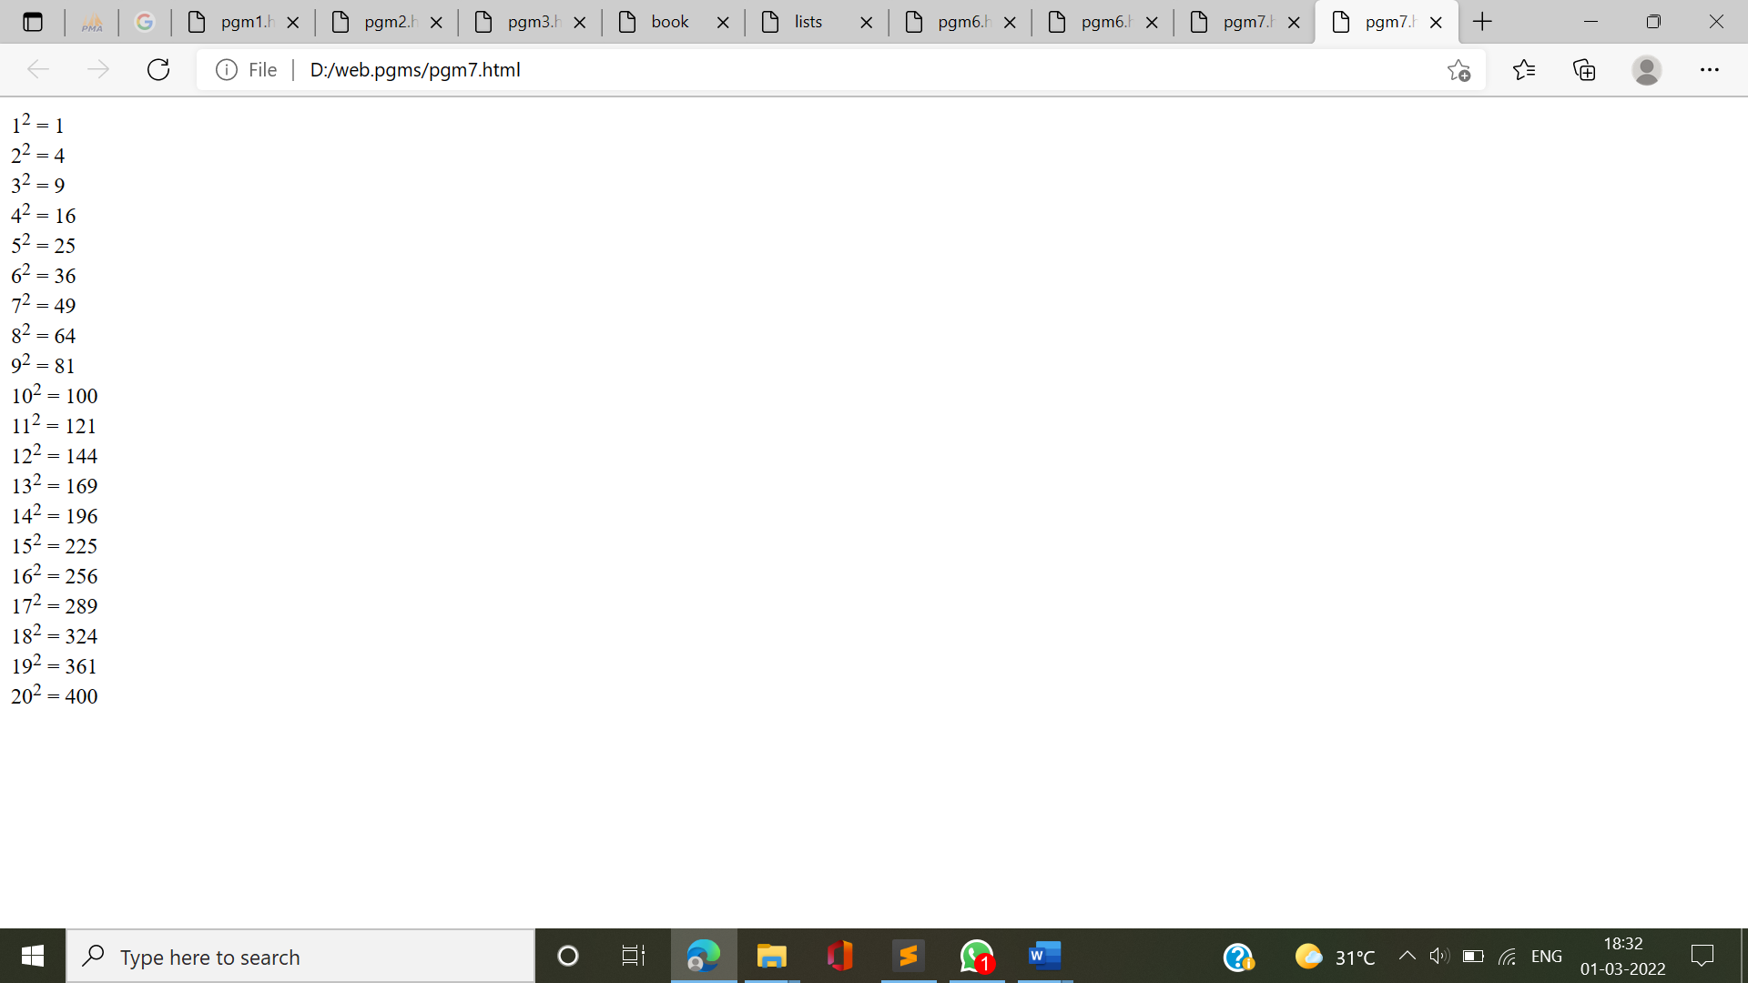

**8.** Print a definition list with 5 items.

**INPUT:**

<!DOCTYPE html>

<html>

<head>

<title></title>

</head>

<body>

<dl>

<dt>Arrays</dt>

<dd>An array is a collection of homogeneous (same type) data items stored in contiguous memory locations. </dd>

<dt>Searching Arrays</dt>

<dd>Searching is the process of looking for a specific element in an array</dd>

<dt>Linear Search</dt>

<dd>The linear search approach compares the key element, key, with each element in the array list[]. </dd>

<dt>Binary Search</dt>

<dd>For binary search to work, the elements in the array must already be ordered. </dd>

</dl>

</body></html>

**OUTPUT:**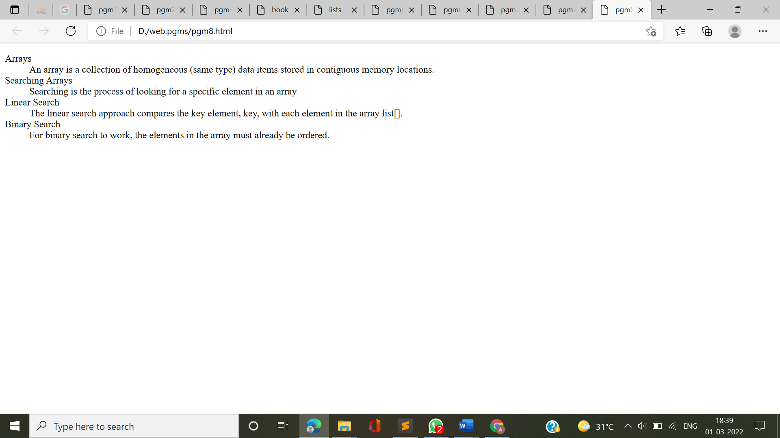

**9.** Display an image that has a border of size 2, a width of 200, and a height of 200.

**INPUT:**

<html>

<head>

<title></title>

</head>

<body>

<img src="duck.jpg" width="200" height="200" border="2" />

</body>

</html>

**OUTPUT:**

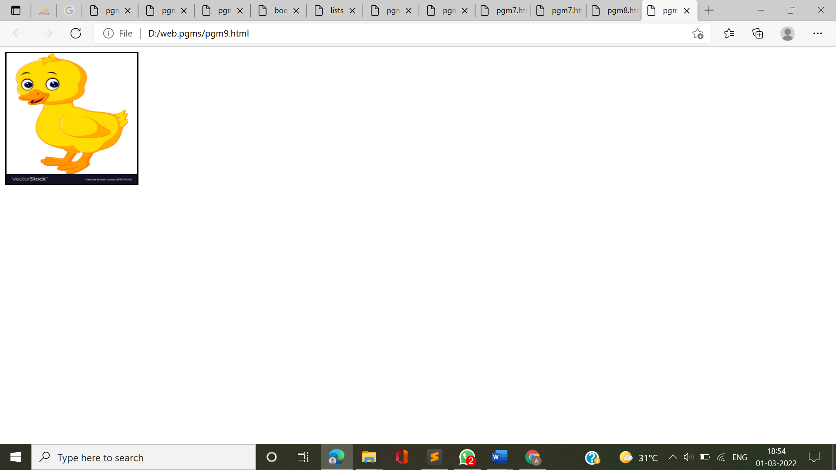

**10.** Print ten acronyms and abbreviations of your choosing, each separated by two lines. Specify the data that the abbreviations and acronyms represent.

**INPUT:**

<html>

<head>

<title></title>

</head>

<body>

<abbr title="Abstract">Abstr.</abbr>

<br /><br />

<abbr title="Biochemistry">Biochem.</abbr>

<br /><br />

<abbr title="Example">Ex.</abbr>

<br /><br />

<abbr title="Literature">Lit.</abbr>

<br /><br />

<abbr title="Mathematics">Math.</abbr>

<br /><br />

<acronym title="World Wide Web Consortium">W3C</acronym>

<br /><br />

<acronym title="Institute of Electrical

and Electronic Engineers">IEEE</acronym>

<br /><br />

<acronym title="International Standards Organization">

ISO

</acronym>

<br /><br />

<acronym title="Hyper Text Markup Language">HTML</acronym>

<br /><br />

<acronym title="Beginners All Purpose

Symbolic Instruction Code">BASIC

</acronym>

</body>

</html>

**OUTPUT:**

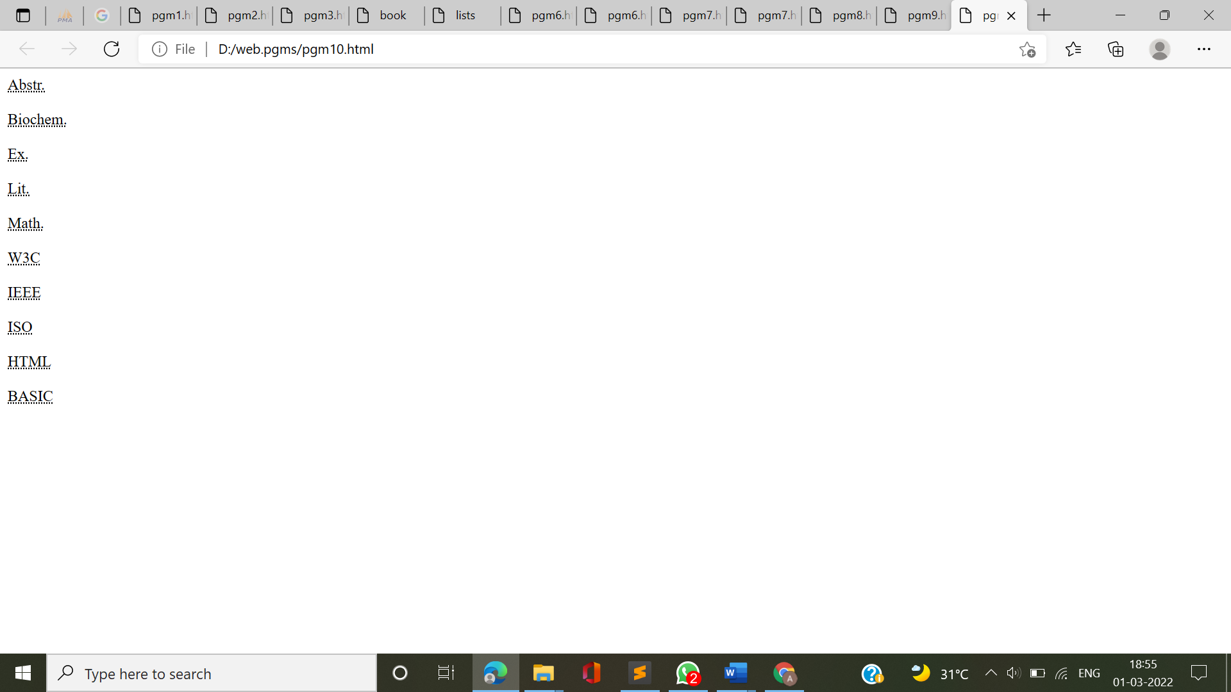

**11.** Print two addresses in the same format used on the front of envelopes (senders address in top left corner, receivers address in the center.

**INPUT:**

<html>

<head>

<title></title>

</head>

<body>

<address>

Dilbert H.<br />

1234 Anim Street<br />

P.O. Box 22222

</address>

<br /><br />

<address style="text-align: center;">

Someone A. Person<br />

5555 Street Avenue<br />

Metrpolitan, Metropolis 11111

</address>

</body>

</html>

**OUTPUT:**

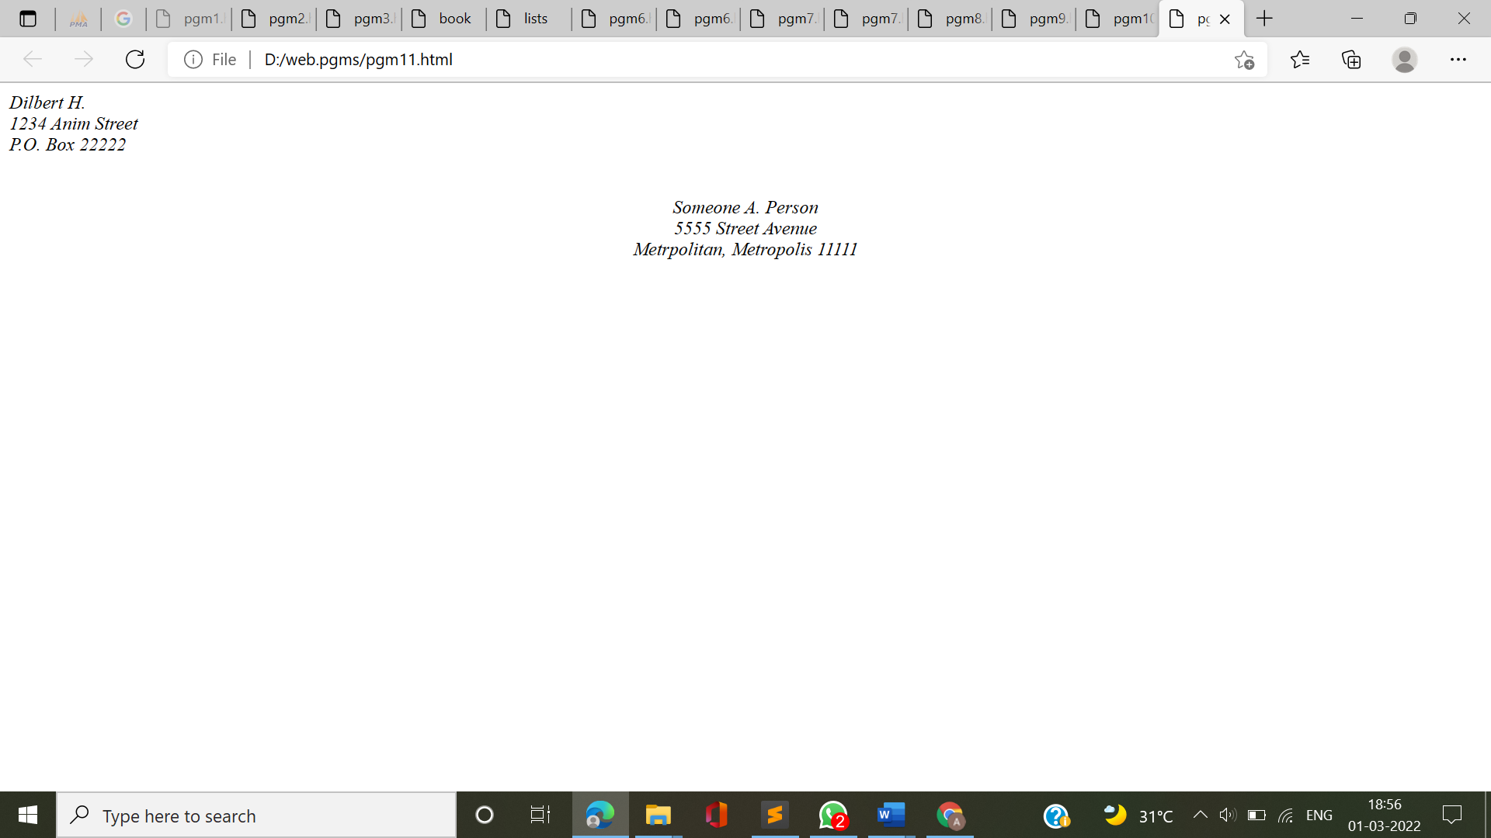**12.** Create an HTML page with the following contents:

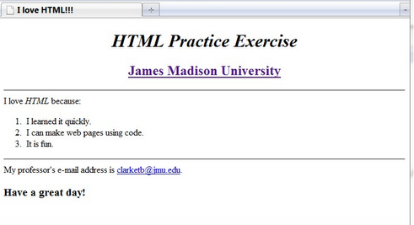

**INPUT:**

<html>

<head>

<title>I LOVE HTML!!!</title>

</head>

<body>

<h1 align="center">HTML Practice Exercise</h1>

<h3 style="color: blue;text-align: center;"><u>James Madison University</u></h3>

<hr>

<p>I Love HTML Because:</p>

<ol>

<li>I learned it quickly.</li>

<li>I can make webpags using codes.</li>

<li>It is fun</li>

</ol>

<hr>

<p>My professor's email address is <a href="">clarketb@jmu.edu</a></p>

<h1>Have a great day!</h1>

</body>

</html>

**OUTPUT:**

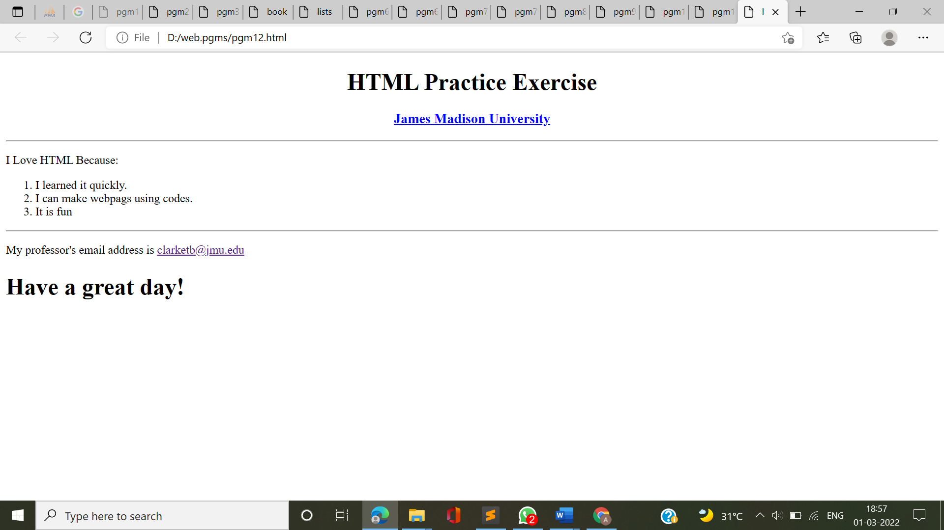

**13.** Create the following table

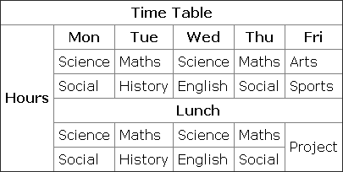

**INPUT:**

<html>

<head>

<title></title>

</head>

<body>

<style>

table, th, td {

border: 1px solid black;

border-collapse: collapse;

}

th,td{

padding: 10px;

}

</style>

<table align="center" >

<tr>

<td align="center" colspan="6"><b>TIME TABLE</b></td>

</tr>

<tr>

<td rowspan="6"><b>Hours</b></td>

<td align="center"><b>Mon</b></td>

<td align="center"><b>Tue</b></td>

<td align="center"><b>Wed</b></td>

<td align="center"><b>Thu</b></td>

<td align="center"><b>Fri</b></td>

</tr>

<tr>

<td align="center">Science</td>

<td align="center">Maths</td>

<td align="center">Science</td>

<td align="center">Maths</td>

<td align="center">Arts</td>

</tr>

<tr>

<td align="center">Social</td>

<td align="center">History</td>

<td align="center">Englsh</td>

<td align="center">Social</td>

<td align="center">Sports</td>

</tr>

<tr>

<td colspan="5" align="center"><b>LUNCH</b></td>

</tr>

<tr>

<td align="center">Science</td>

<td align="center">Maths</td>

<td align="center">Science</td>

<td align="center">Maths</td>

<td rowspan="2" colspan="2">Project</td>

</tr>

<tr>

<td align="center">Social</td>

<td align="center">History</td>

<td align="center">English</td>

<td align="center">Social</td>

</tr>

</table>

</body>

</html>

**OUTPUT:**

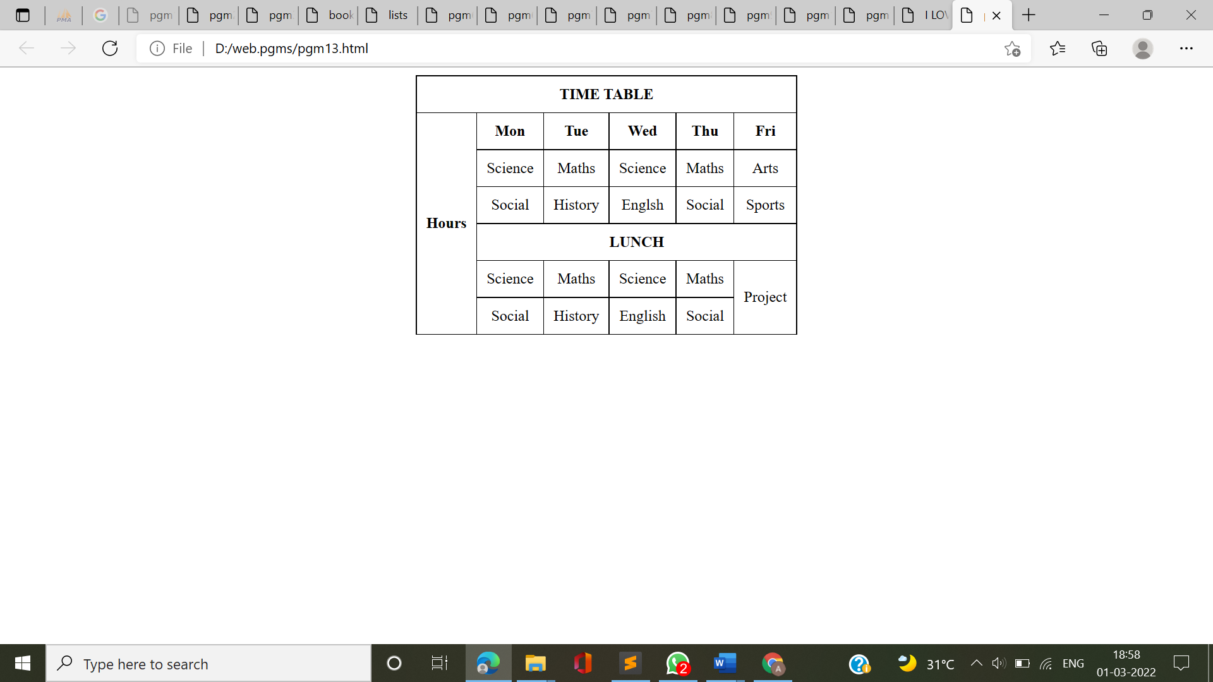

**14.** Create a HTML Page which looks like the one given below

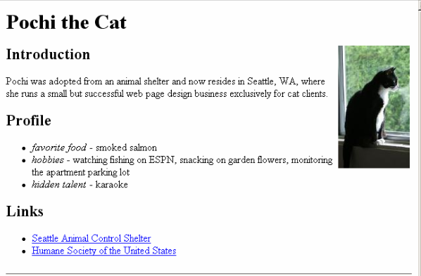

**INPUT:**

<html>

<head>

<title></title>

</head>

<style type="text/css">

body{

font-family: times new roman;

font-size: 20px;

}

</style>

<body>

<h1>Pochi the cat</h1>

<p>

<img src="cat.jpg" style="float:right;width:200px;height:300px;">

<h2>Introduction</h2>

<p>Pochi was adopted from an animal sheltet and now resides in Seattle, WA,Where she runs a small but successful web page design business exclusively for cat clients. </p>

<h2>Profile</h2>

<ul>

<li><i>favorite food</i>-smoked salmon</li>

<li><i>hobbies</i>-watching fishing on ESPN, snacking on garden flowers, monitoring the apartmet parking lot</li>

<li><i>hidden talent</i>-karaoke</li>

</ul>

<h2>Links</h2>

<ul>

<li><a href="">Seattle Animal Control Shelter</a></li>

<li><a href="">Humane Society of the United States</a></li>

</ul>

</body>

</html>

**OUTPUT:** 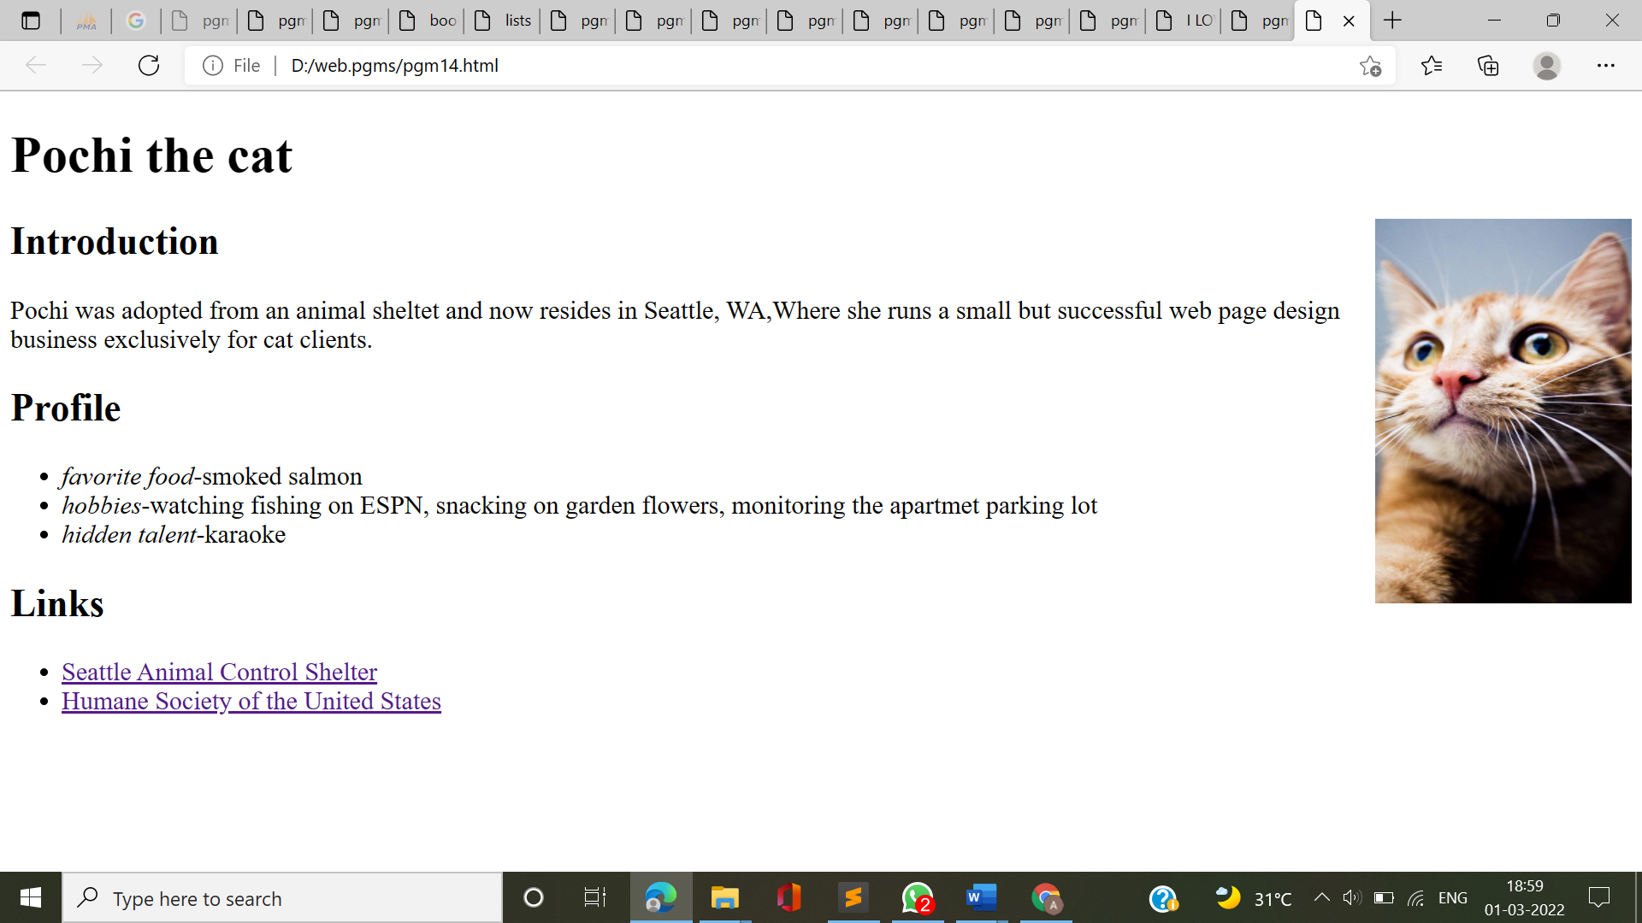

**15.** Create an Html file by applying the different styles using inline ,external and internal style sheets.

**INPUT:**

<html>

<head>

<style>

h1

{

color: brown;

font-family: 'Lucida Sans', 'Lucida Sans Regular', 'Lucida Grande', 'Lucida Sans Unicode',

Geneva, Verdana, sans-serif;

font-size: 20px;

text-align: center;

}

</style>

<title>Inline and Internal Styling </title>

</head>

<body>

<p style="color: blue; text-align: center">Inline Styling</p>

<h1>Internal Styling</h1>

</body>

</html>

<html>

<head>

<link rel="stylesheet" href="mystyle.css" >

<title>External Styling </title>

</head>

<body>

External Styling

</body>

</html>

body

{

color: blueviolet;

text-align: center;

font-size: 30px;

}

**OUTPUT:**

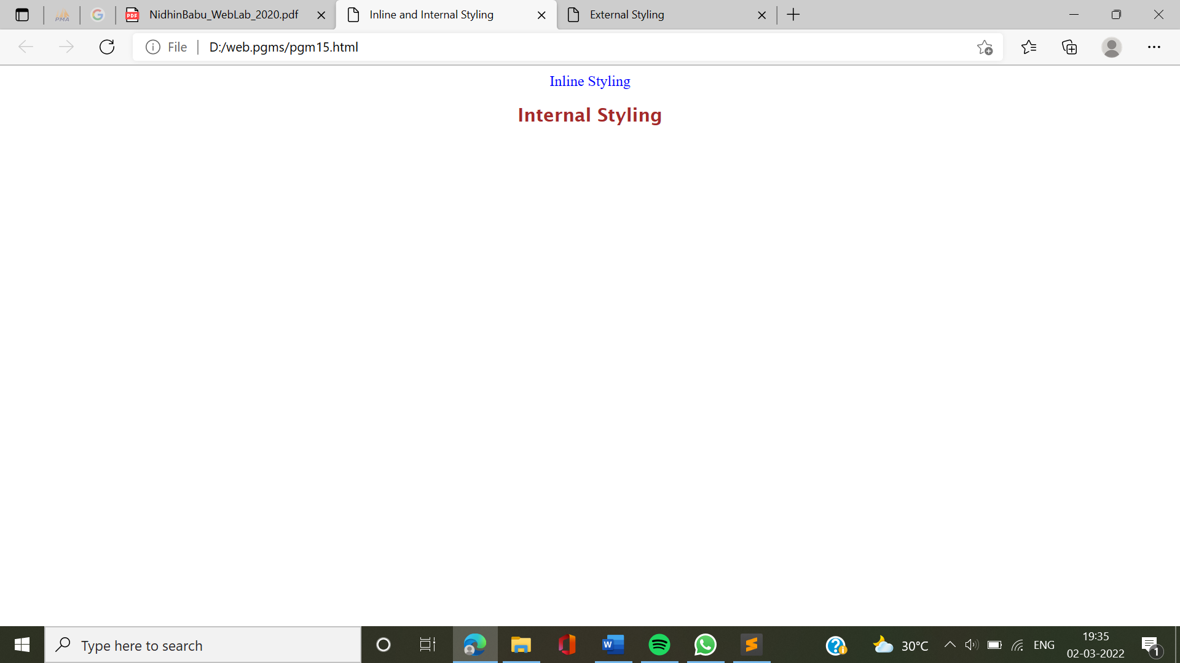

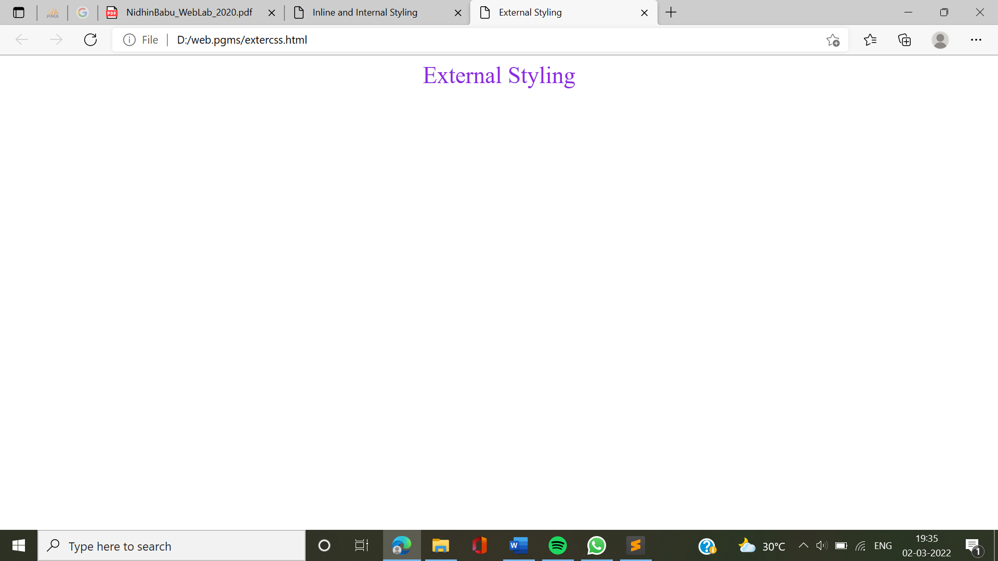

**16.** Create a registration form using html.

**INPUT:**

<html>

<head>

<link rel="stylesheet" href="styles.css">

<title>Registration form </title>

</head>

<body>

<h1 style="text-align: center;">REGISTRATION FORM</h1>

<form>

<label>Enter your name:</label>

<input type="text" name="Name/"></br><br>

<label>Enter your age:</label>

<input type="text" name="age"/></br><br>

<label>Gender:</label>

<input type="radio" name="gender"/>Male

<input type="radio" name="gender"/>Female

<input type="radio" name="gender"/>Other</br>

<input type="submit" name="submit" value="Submit"/>

</form>

</body>

</html>

**OUTPUT:**

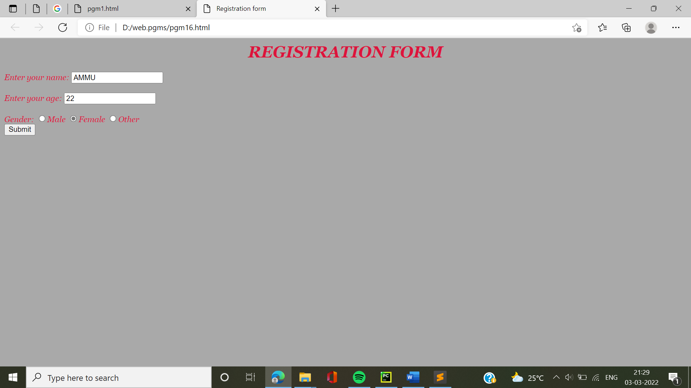

**17.** Create an Html page to explain the use of various predefined functions in a string and math object in JavaScript.

**INPUT:**

<html>

<head>

<title>Predefined functions in string and math</title>

<style>

body

{

text-align: center;

font-family: verdana;

font-size: 25px;

}

</style>

</head>

<body>

<script>

document.write("<h2>Predefined functions of string and math object</h2>")

var num=Math.round(4.4)

document.write("Rounding a number using Math.round", +num);

var str="Hello World";

document.write("<br>")

document.write("Character at 0th position of "+str+" is:"+str.charAt(0));

var c=50.65

var x=Math.ceil(c)

document.write("<br>Value of "+c+" after using Math.ceil is:"+x);

var lw="web programming";

document.write("<br>"+lw+" to upper case:"+lw.toUpperCase());

var power=Math.pow(3,2);

document.write("<br> Math.pow(3,2) gives:"+power);

</script>

</body>

</html>

**OUTPUT:**

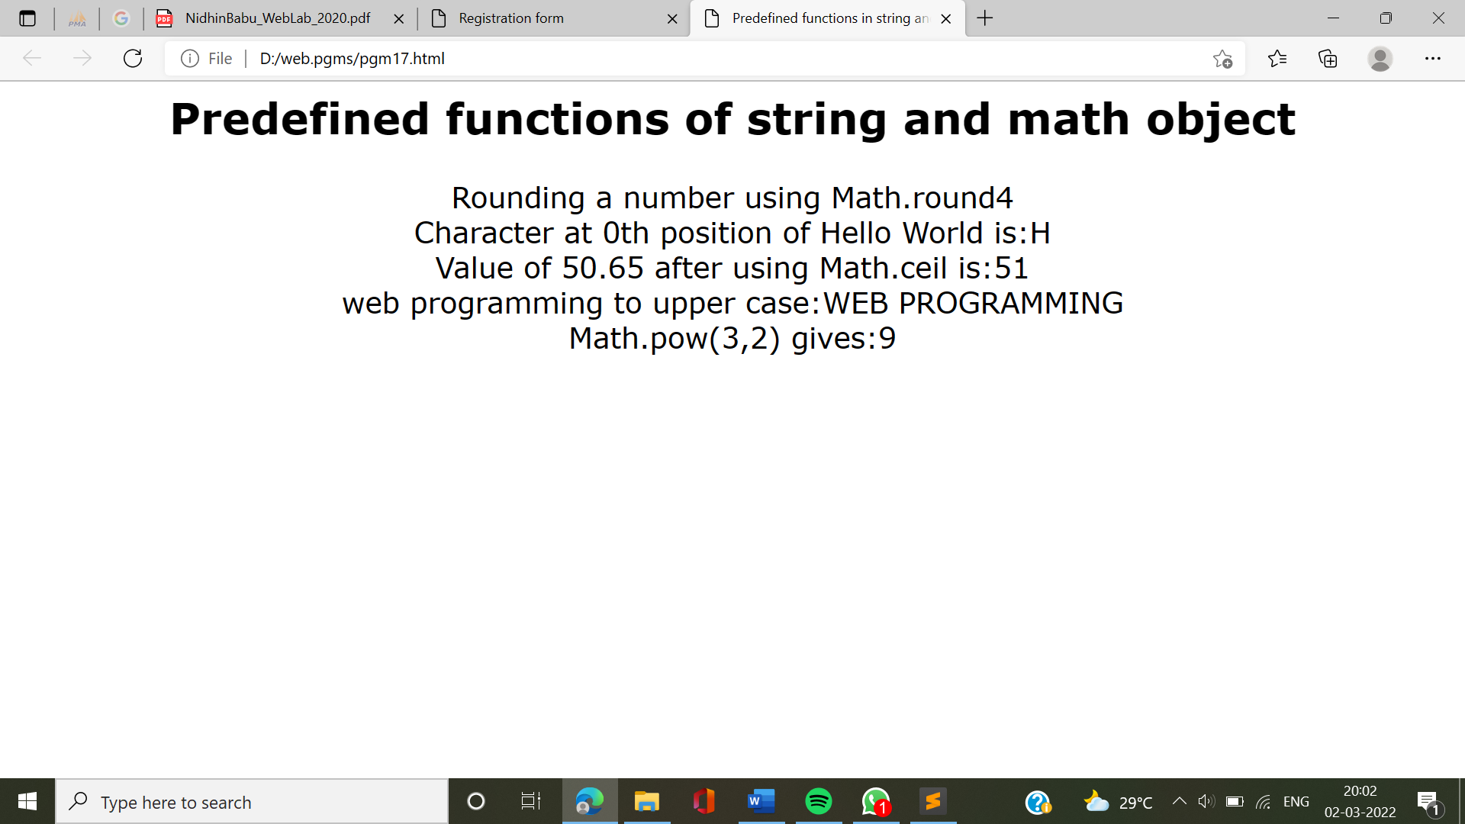

**18.** Generate the calender using JavaScript code and by getting the year from the user.

<html>

<head>

<script language="javascript">

function day_title(day_name)

{

document.write("<td align=center width=30 bgcolor=green><b>"+day_name+"</b></td>");

}

function fill_table(month,month_len)

{

day=1;

document.write("<table border=1 cellspacing=2 cellpadding=3%>");

document.write("<td colspan=7 align=center bgcolor=Yellow><b>"+month+" "+year+"</b><tr>"); day_title("SUN");

day_title("MON");

day_title("TUE");

day_title("WED");

day_title("THU");

day_title("FRI");

day_title("SAT");

document.write("</tr><tr>");

for(var i=1; i<start_day;i++)

{

document.write("<td>");

}

for(var i=start_day; i<8;i++)

{

document.write("<td align=center bgcolor=orange>"+day+"</td>");

day++;

}

document.write("<tr>");

while(day<=month_len)

{

for(var i=1; i<=7 && day<=month_len;i++)

{

document.write("<td align=center bgcolor=orange>"+day+"</td>");

day++;

}

document.write("<tr>");

start_day=i;

}

document.write("</tr></table><br>");

}

year=prompt("Enter The Year ",2020);

today=new Date("January 1, "+year);

start_day=today.getDay()+1;

fill_table("January", 31);

if (year%4==0)

fill_table("February", 29);

else

fill_table("February", 28);

fill_table("March", 31);

fill_table("April", 30);

fill_table("May", 31);

fill_table("June", 30);

fill_table("July", 31);

fill_table("August", 31);

fill_table("September", 30);

fill_table("October", 31);

fill_table("November", 30);

fill_table("December", 31);

</script>

</head>

</html>

**OUTPUT:** 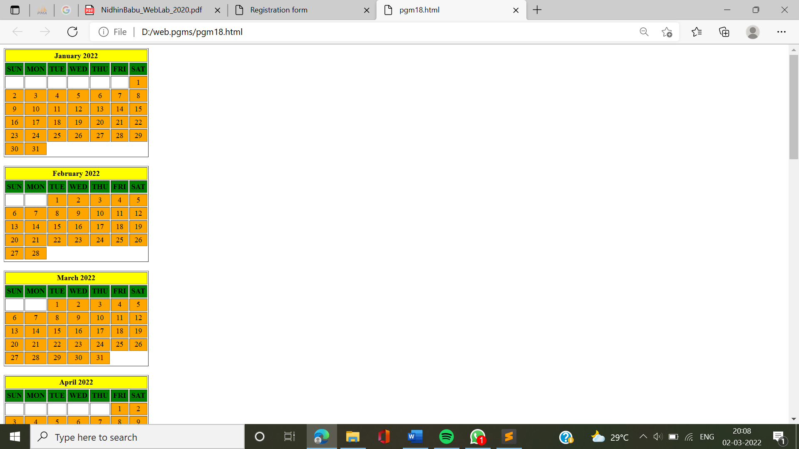

**19.** Create HTML registration form and to validate the form using JavaScript.

**INPUT:**

<html>

<head>

<script>

function validate()

{

var name = document.forms["RegForm"]["Name"];

var email = document.forms["RegForm"]["EMail"];

var phone = document.forms["RegForm"]["Telephone"];

var what = document.forms["RegForm"]["Subject"];

var password =document.forms["RegForm"]["Password"];

var address = document.forms["RegForm"]["Address"];

if (name.value == "")

{

window.alert("Please enter your name.");

name.focus();

return false;

}

if (address.value == "")

{

window.alert("Please enter your address.");

address.focus();

return false;

}

if (email.value == "")

{

window.alert( "Please enter a valid e-mail address.");

email.focus();

return false;

}

if (phone.value == "")

{

window.alert( "Please enter your telephone number.");

phone.focus();

return false;

}

if (password.value == "")

{

window.alert("Please enter your password");

password.focus();

return false;

}

if (what.selectedIndex < 1)

{

window. alert("Please enter your course.");

what.focus();

return false;

}

return true;

}

</script>

<style>

body

{

text-align: center;

}

</style>

</head>

<body>

<h1 style="text-align: center;">REGISTRATION FORM</h1>

<form name="RegForm" onsubmit="return validate()">

<p>Name: <input type="text"size="65" name="Name" /></p>

<br />

<p>Address: <input type="text" size="65" name="Address" />

</p>

<br />

<p>E-mail Address: <input type="text" size="65" name="Email" /></p>

<br />

<p>Password: <input type="password" id="pass" name="password"

minlength="8" required></p>

<br />

<p>Telephone: <input type="text" size="65" name="Telephone" /></p>

<br /><p>

SELECT YOUR COURSE

<select type="text" value="" name="Subject"><option>BTECH</option>

<option>BCA</option>

<option>MCA</option>

<option>M.TECH</option>

</select>

</p>

<br />

<br />

<input type="submit" value="Submit" name="Submit" />

<input type="reset" value="Reset" name="Reset" />

</p>

</form>

</body>

</html>

**OUTPUT:**

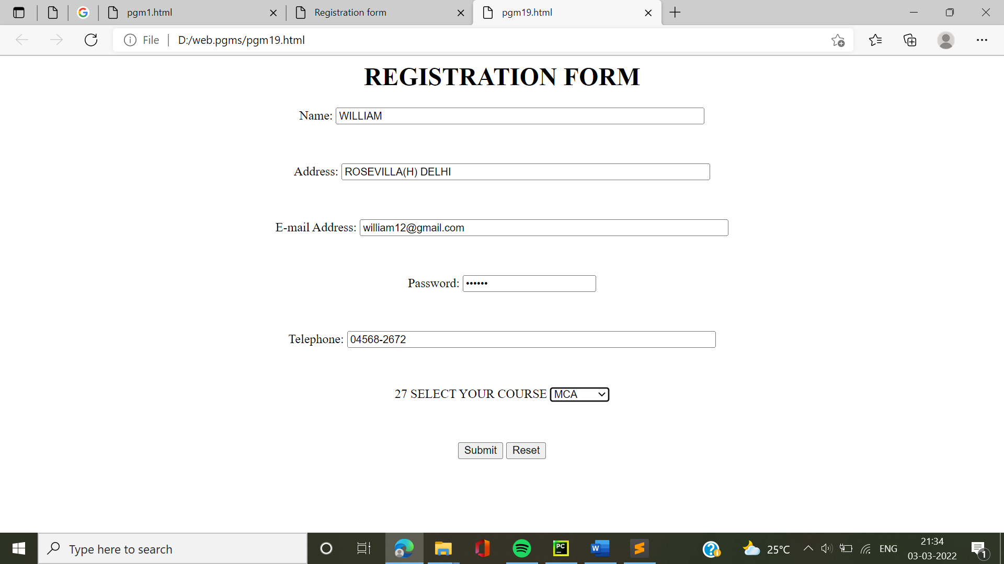

**20.** Create a html page to change the background color for every click of a button using JavaScript Event Handling.

**INPUT:**

<html>

<head>

<title>Change the Background Color with JavaScript</title>

<script>

function changeBodyBg(color)

{

document.body.style.background = color;

}

</script>

</head>

<body>

<h1>Welcome to my page</h1>

<label>Change Webpage Background To:</label>

<button type="button" onclick="changeBodyBg('pink');">pink</button>

<button type="button" onclick="changeBodyBg('blue');">blue</button>

<button type="button" onclick="changeBodyBg('green');">green</button>

</body>

</html>

**OUTPUT:**

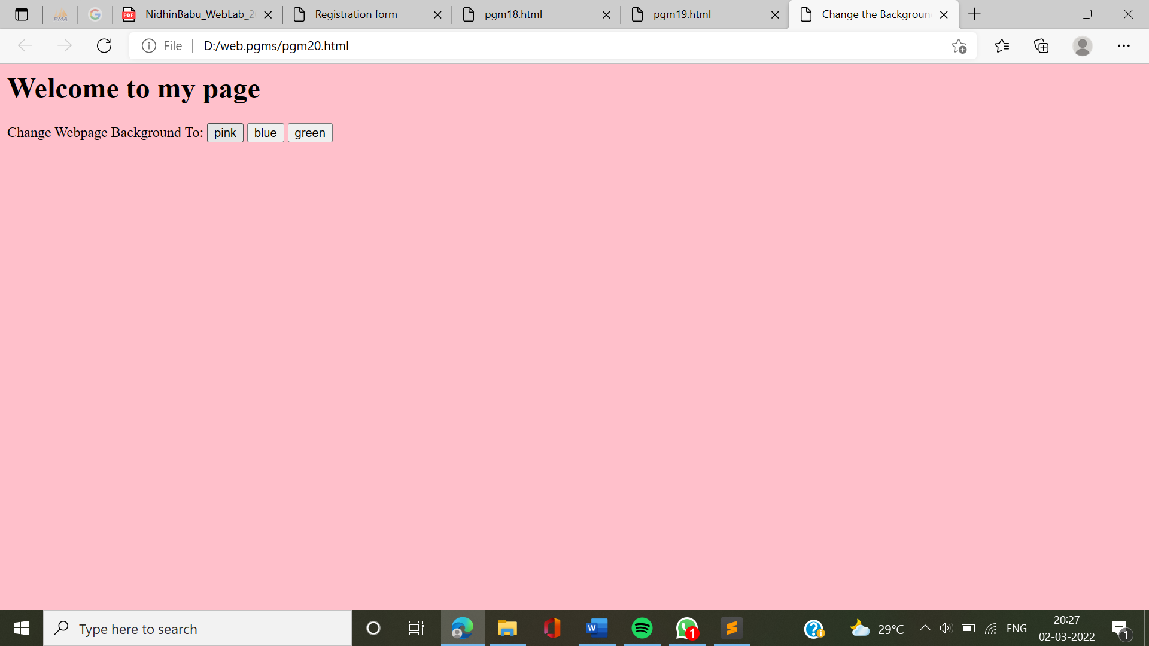

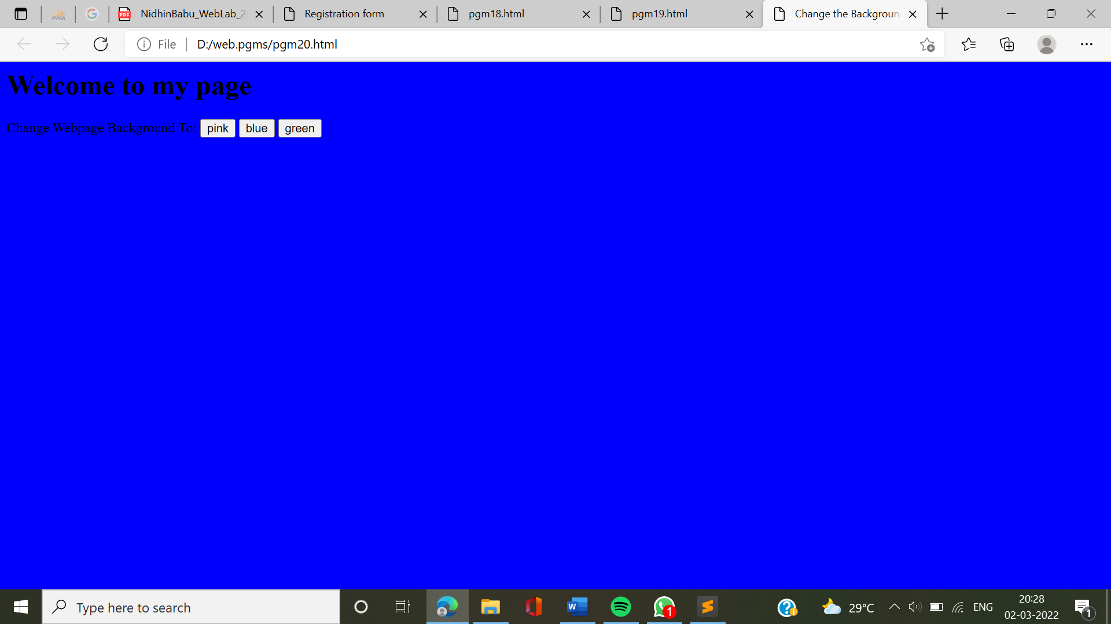

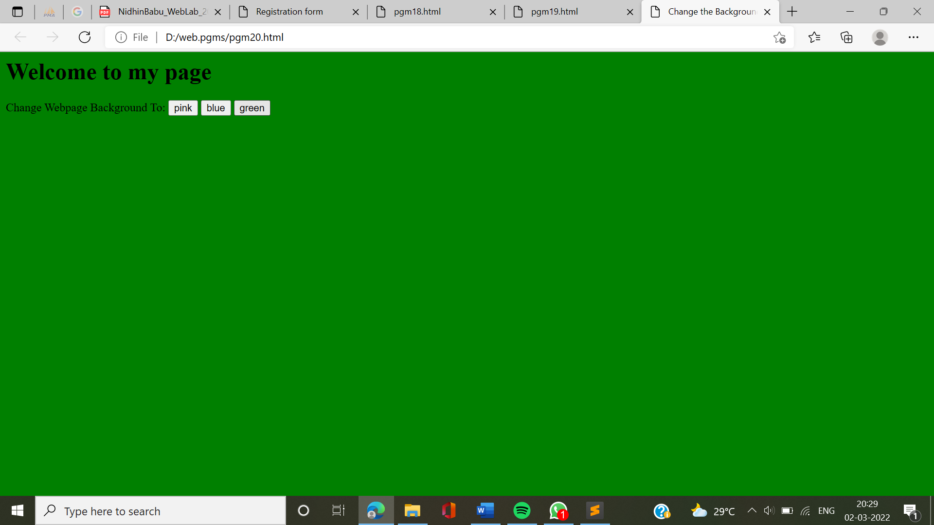

**21.** Create a html page to display a new image and text when the mouse comes over the existing content in the page using JavaScript Event Handling.

**INPUT:**

<html>

<head>

<script language="javascript">

function preload()

{

topon=new Image(100,50);

topon.src="nature.jpg"; topoff=new

Image(260,280); topoff.src="tree.jpg";

}

function myMouseOn(n)

{

preload();

imageON=eval(n+"on.src");

document.images[n].src=imageON;

}

function myMouseOff(n)

{

imageOFF=eval(n+"off.src");

document.images[n].src=imageOFF;

}

</script></head>

<body ><h1> Demo for mouse over</h1>

<a href="#" onMouseOut="myMouseOff('top')";

onMouseOver="myMouseOn('top')";>

<img src="flower.jpg" alt="Show Next" name="top">

</a>

</body>

</html>

**OUTPUT:**

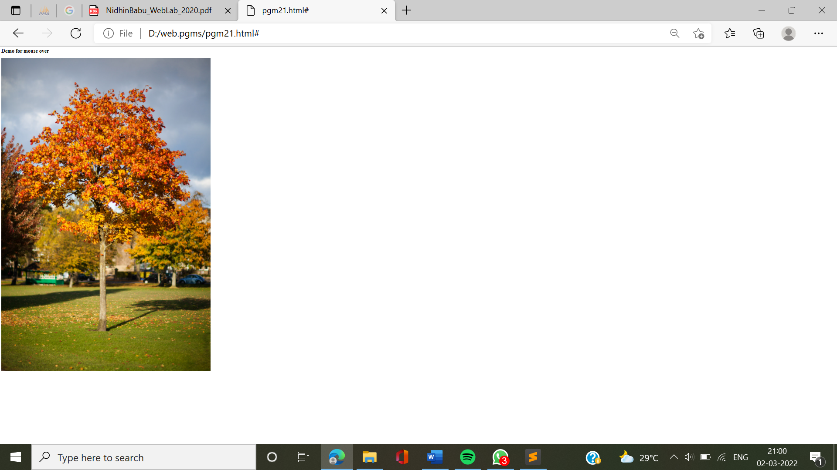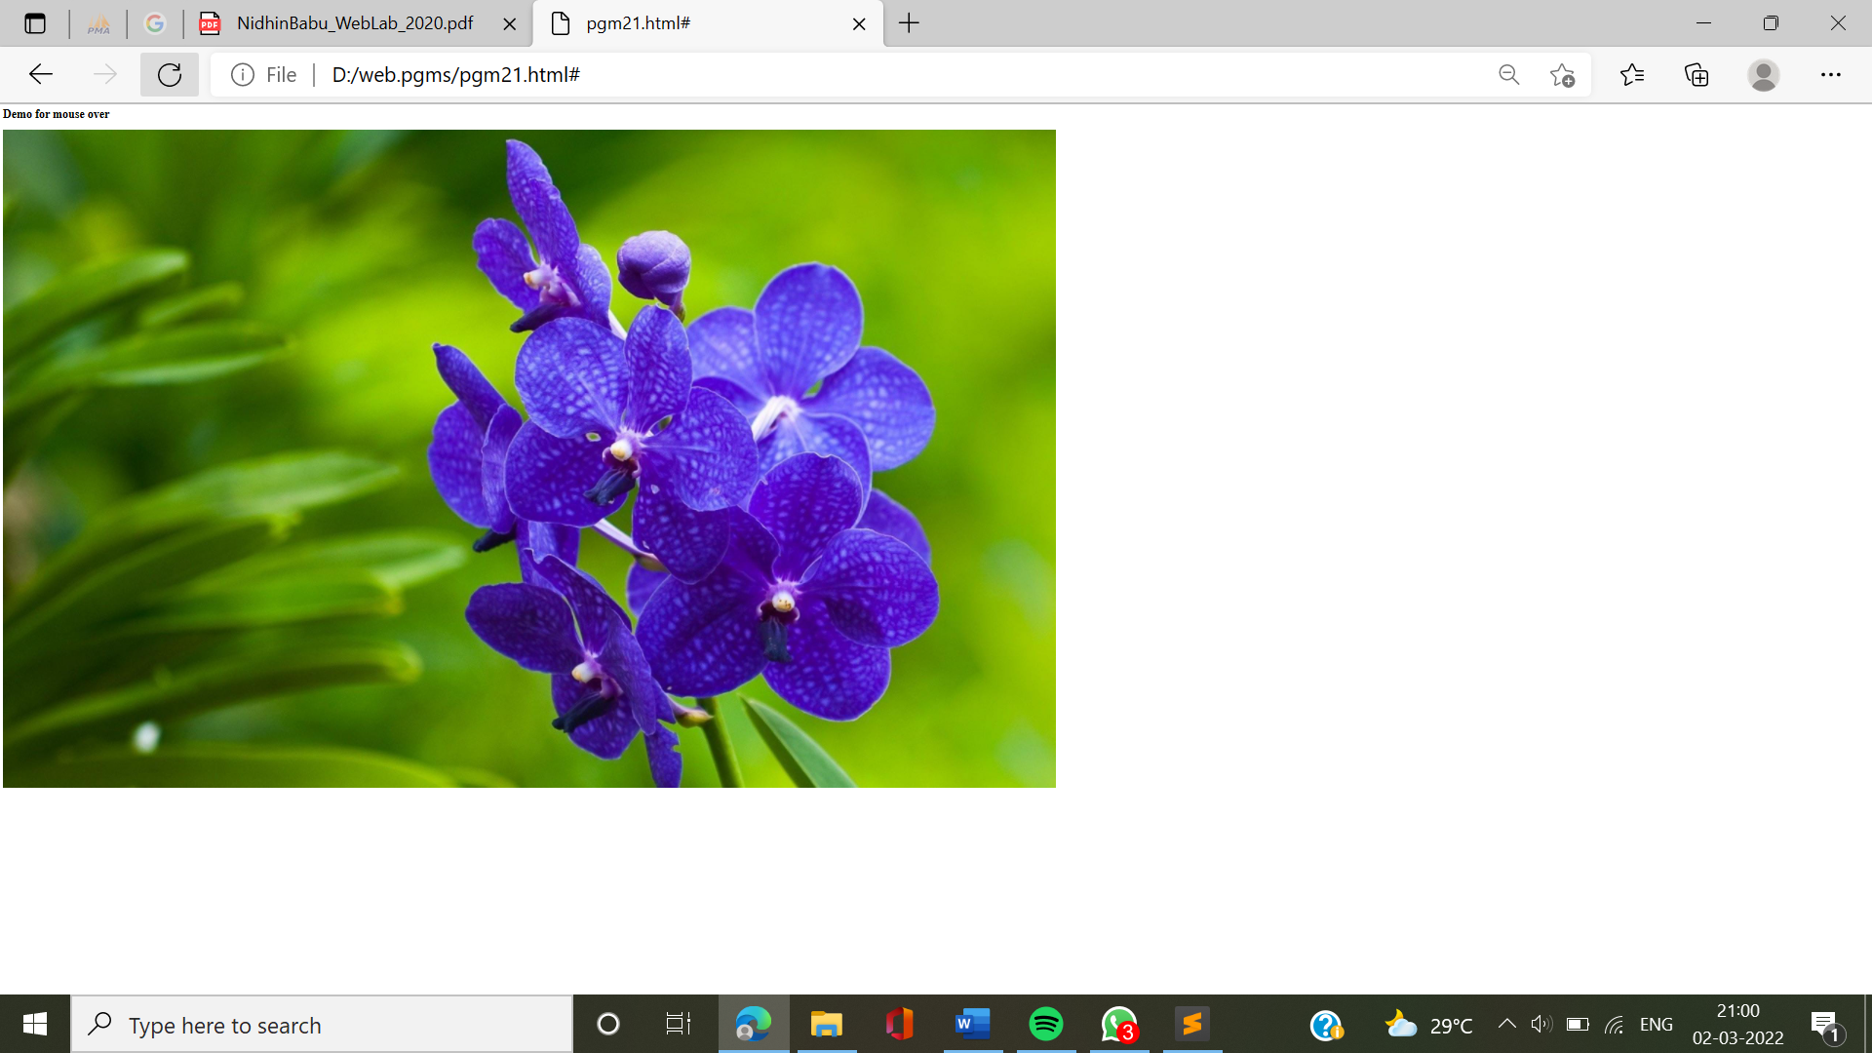

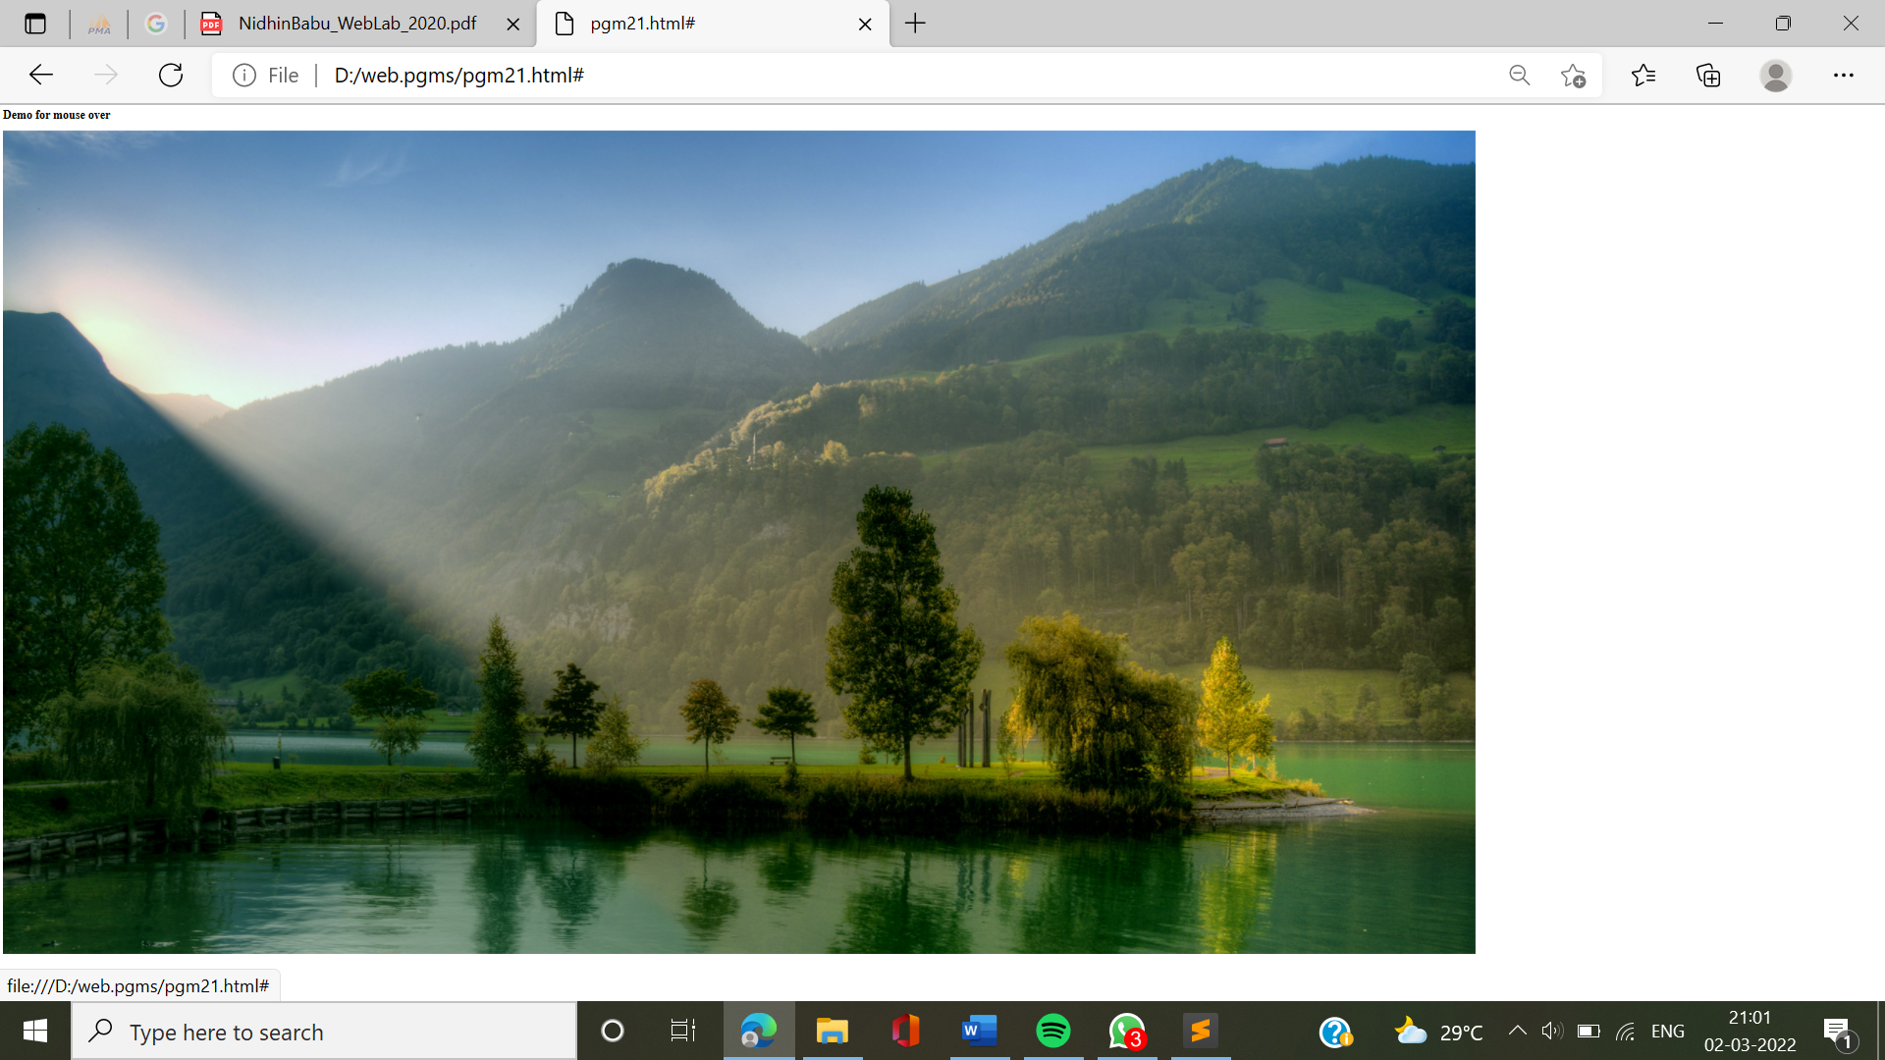

**22.** Create html page to show online exam using JavaScript.

**INPUT:**

<html>

<head>

<title>Exam</title>

<script language="javascript"> function

exam(form)

{

var i=0;

if(form.one[2].checked) i=i+1;

if(form.three[0].checked) i=i+1;

if(form.four[0].checked) i=i+1;

if(form.five[1].checked) i=i+1;

window.alert("Thank You For Taking This Online Exam!!!! Your Score is: "+i);

}

</script>

</head>

<body bgcolor=silver>

<form onSubmit="exam(this)">

<center><h1><blink>WELCOME TO ONLINE EXAM FORM</blink></h1></center>

<p>

<h1>1)Which is platform independent language</h1>

<input type="radio" name="one" value="c++">

<label>c++</label>

<input type="radio" name="one" value="c">

<label>c</label>

<input type="radio" name="one" value="java">

<label>java</label>

<input type="radio" name="one"value="basic">

<label>BASIC</label>

</p>

<p>

<h1>2) Which is class of all class in java</h1>

<input type="radio" name="three" value="object">

<label>Object</label>

<input type="radio" name="three" value="math">

<label>Math</label>

<input type="radio" name="three" value="system">

<label>System</label>

<input type="radio" name="three" value="graphic">

<label>Graphic</label>

</p>

<p>

<h1>3)Frame package is in which package</h1>

<input type="radio" name="four" value="awt">

<label>AWT</label>

<input type="radio" name="four" value="applet">

<label>Applet</label>

<input type="radio" name="four" value="lang">

<label>Lang</label>

<input type="radio" name="four" value="swing">

<label>Swing</label>

</p>

<p>

<h1>4)Java does not support</h1>

<input type="radio" name="five" value="inheritance">

<label>Inheritance</label>

<input type="radio" name="five" value="multiple inheritance">

<label>Multilple inheritance</label>

<input type="radio" name="five" value="polymorphism">

<label>Polymorphism</label>

<input type="radio" name="five" value="encryption">

<label>Encryption</label>

</p>

<p>

<center>

<input type="submit" value="Submit">

<input type ="reset" value="Reset">

</center></p>

</body>

</html>

**OUTPUT:**

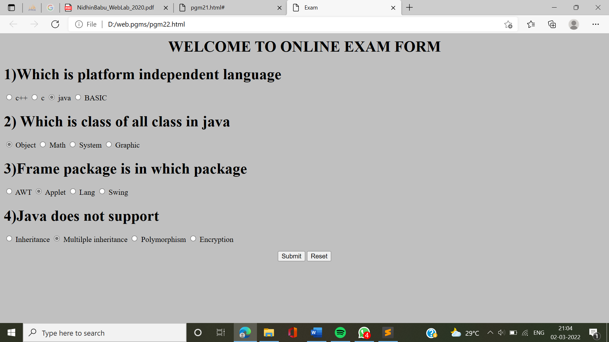

**23.** Using PHP and MySQL ,develop a program.

**INPUT:**

Sample_conn.php

<html>

<head>

<title>Connecting MySQL Server</title>

</head>

<body>

<?php

$dbhost = 'localhost';

$dbuser = '21mca003';

$dbpass = '2273';

$mysqli = new mysqli($dbhost, $dbuser, $dbpass);

if($mysqli->connect_errno ) {

printf("Connect failed: %s<br />", $mysqli->connect_error);

exit();

}

printf('Connected successfully.<br />');

$mysqli->close();

?>

</body>

</html>

Create database.php

<html>

<head><title>Creating MySQL Database</title></head>

<body>

<?php

$dbhost = 'localhost';

$dbuser = '21mca003';

$dbpass = '2273';

$mysqli = new mysqli($dbhost, $dbuser, $dbpass);

if($mysqli->connect_errno ) {

printf("Connect failed: %s<br />", $mysqli->connect_error);

exit();

}

printf('Connected successfully.<br />');

if ($mysqli->query("CREATE DATABASE sample")) {

printf("Database TUTORIALS created successfully.<br />");

}

if ($mysqli->errno) {

printf("Could not create database: %s<br />", $mysqli->error);

}

$mysqli->close();

?>

</body>

</html>

Create table_book.php

<html>

<head>

<title>Creating MySQL Table</title>

</head>

<body>

<?php

$dbhost = 'localhost';

$dbuser = '21mca003';

$dbpass = '2273';

$dbname = '21mca003';

$mysqli = new mysqli($dbhost, $dbuser, $dbpass, $dbname);

if($mysqli->connect_errno ) {

printf("Connect failed: %s<br />", $mysqli->connect_error);

exit();

}

printf('Connected successfully.<br />');

$sql = "CREATE TABLE book_tb( ".

"book_id INT NOT NULL AUTO_INCREMENT, ".

"book_title VARCHAR(100) NOT NULL, ".

"book_author VARCHAR(40) NOT NULL, ".

"purchase_date DATE, ".

"PRIMARY KEY ( book_id )); ";

if ($mysqli->query($sql)) {

printf("Table book_tb created successfully.<br />");

}

if ($mysqli->errno) {

printf("Could not create table: %s<br />", $mysqli->error);

}

$mysqli->close();

?>

</body>

</html>

Insert_book.php

<!DOCTYPE HTML>

<html>

<body bgcolor="87ceeb">

<center><h2>Simple Library Management System</h2></center>

<br>

<?php

include("DBConnection.php");

$isbn=$_POST["isbn"];

$title=$_POST["title"];

$author=$_POST["author"];

$edition=$_POST["edition"];

$publication=$_POST["publication"];

$query = "insert into book_info(isbn,title,author,edition,publication) values('$isbn','$title','$author','$edition','$publication')";

$result = mysqli_query($db,$query);

?>

<h3> Book information is inserted successfully </h3>

<a href="SearchBooks.php"> To search for the Book information click here </a>

</body>

</html>

Selecting_record.php

<html>

<head>

<style>

table, th, td {

border: 1px solid black;

}

</style>

</head>

<body>

<?php

$servername = "localhost";

$username = "21mca003";

$password = "2273";

$dbname = "21mca003";

$conn = new mysqli($servername, $username, $password, $dbname);

if ($conn->connect_error) {

die("Connection failed: " . $conn->connect_error);

}

$sql = "SELECT * FROM book_tb";

$result = $conn->query($sql);

if ($result->num_rows > 0) {

echo "<table><tr><th>Book_ID</th><th>Book_Title</th><th>Book_Author</th><th>Purchase_Date</th></tr>";

while($row = $result->fetch_assoc()) {

echo "<tr><td>" . $row["book_id"]. "</td>"."<td>" . $row["book_title"]. " </td>" ."<td>" . $row["book_author"]."<td>" . $row["purchase_date"]. " </td></tr>"; }

echo "</table>";

} else {

echo "0 results";

}

$conn->close();

?>

</body>

</html>

**OUTPUT:**

